# MP1

Following codes are in mp1.m

## 1.1

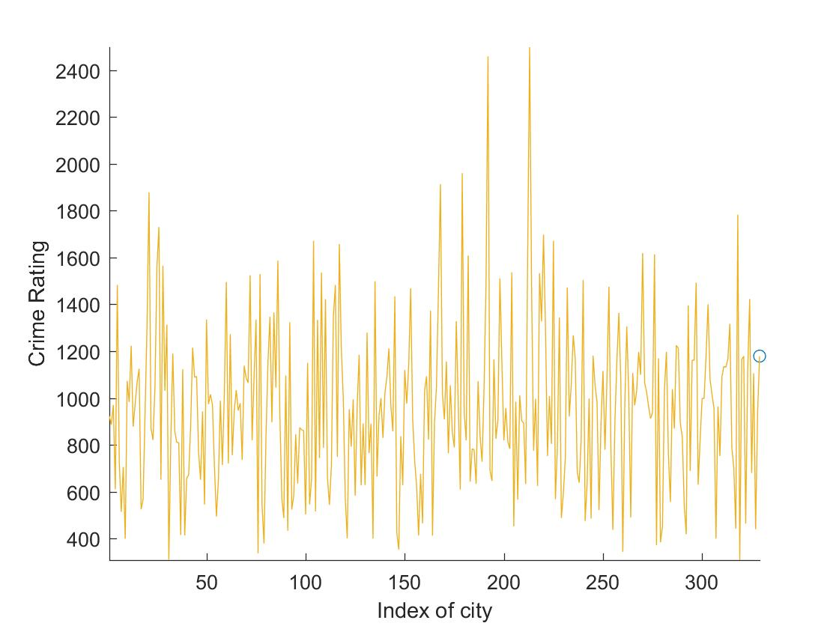

## 1.2

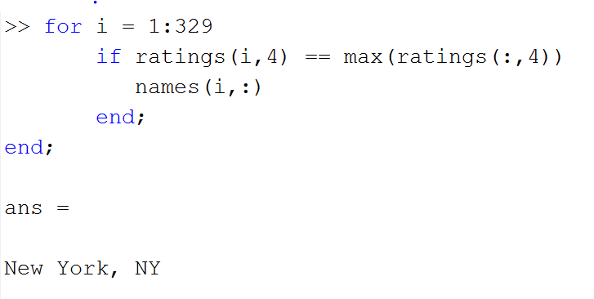

## 2.1

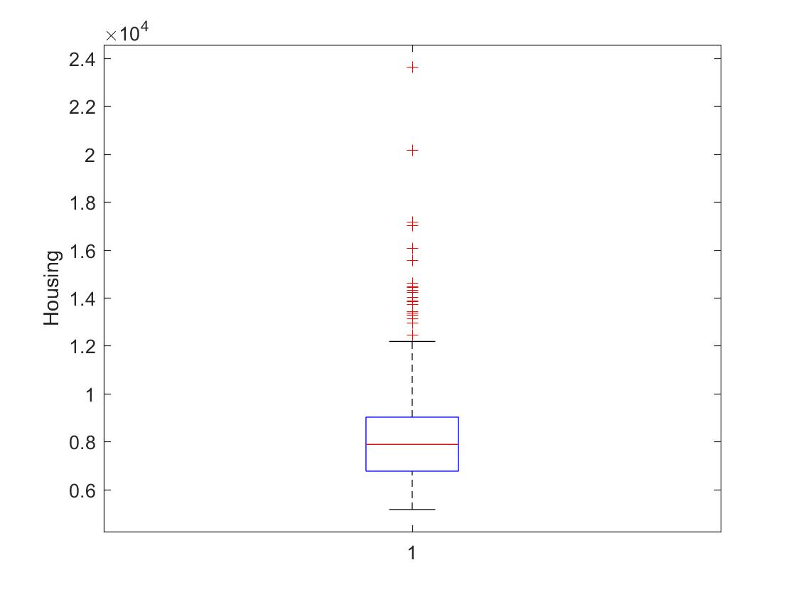

## 2.2

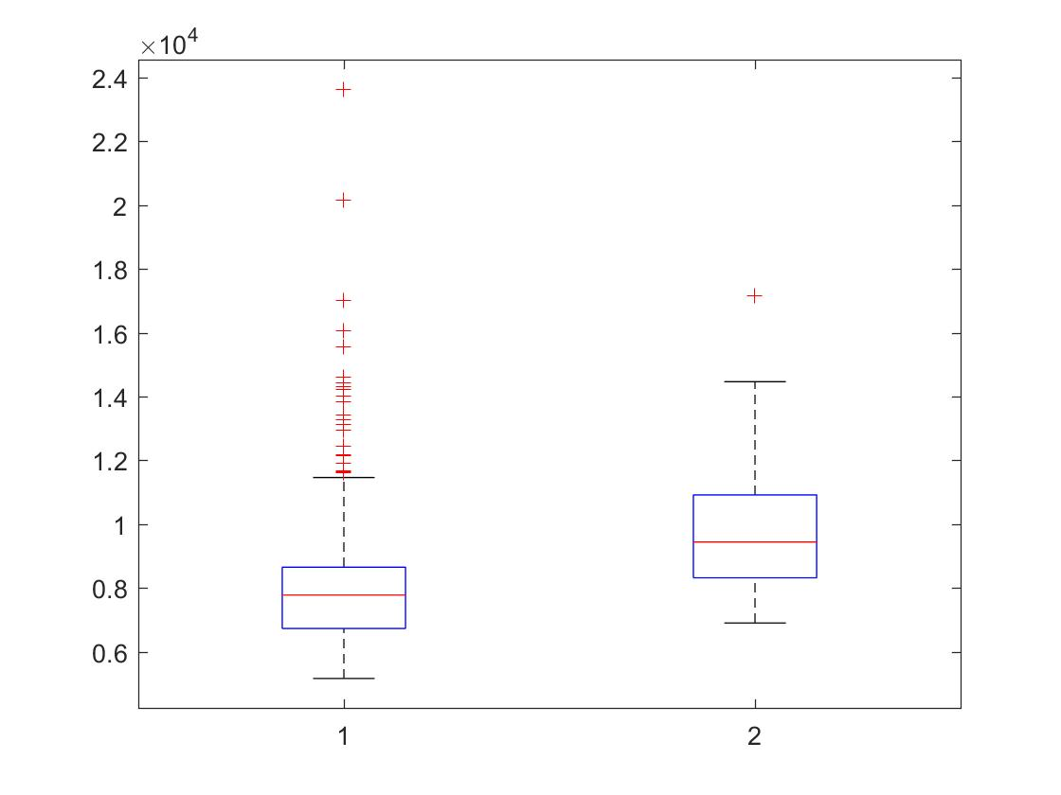

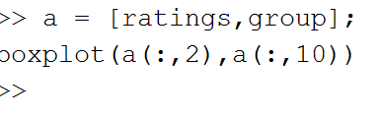

## 3.1

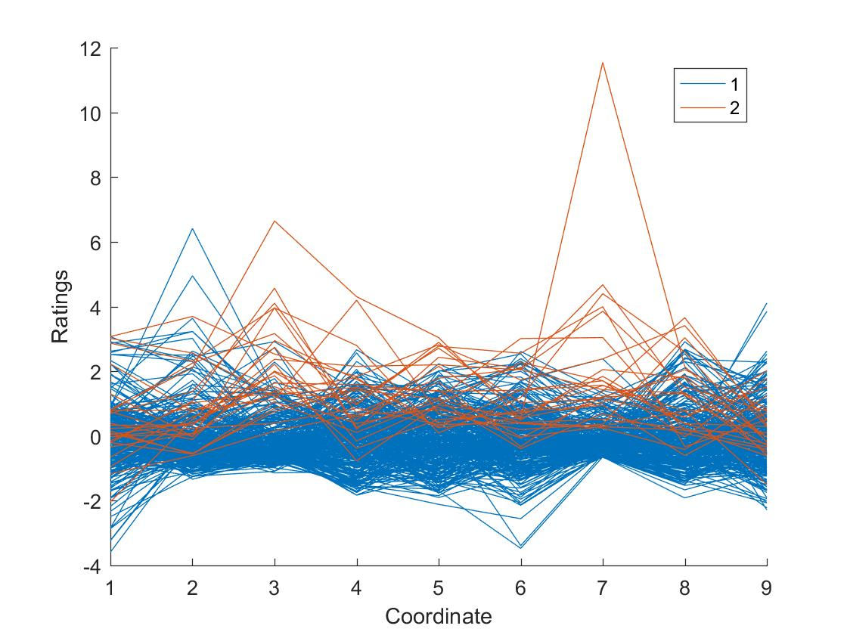

## 3.2

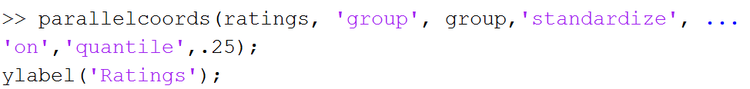

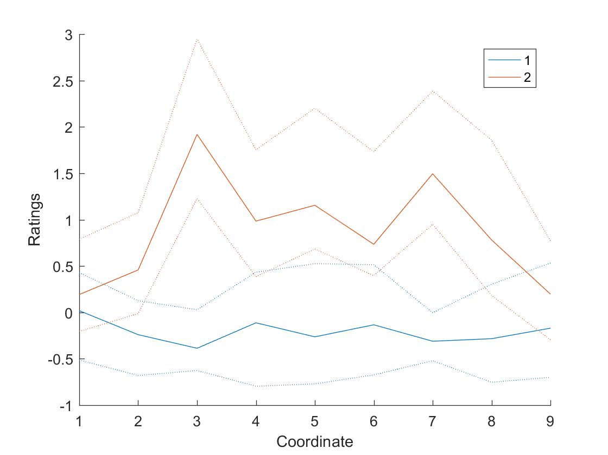

## 3.3

Health is the coordinate 3 and education is 6,

The red line (group 2) is better both in health and education.

## MP3

## 3.a

|  |
| --- |
| function [V,v] = Edit_Dist(str1,str2)  m=length(str1);  n=length(str2);  v=zeros(m+1,n+1);  for i=1:1:m  v(i+1,1)=i;  end  for j=1:1:n  v(1,j+1)=j;  end  for i=1:m  for j=1:n  if (str1(i) == str2(j))  v(i+1,j+1)=v(i,j);  else  v(i+1,j+1)=1+min(min(v(i+1,j),v(i,j+1)),v(i,j));  end  end  end  V=v(m+1,n+1);  End |
| %question 1%  fileID = fopen('customers.csv');    C = textscan(fileID,'%s %s %s %s %s %s %s',...  'Delimiter',',','EmptyValue',-Inf);  fclose(fileID);    Lastname = C{4};  Dist = zeros(401,401);  for i = 2:401  for ii = 2:401  Dist(i,ii) = Edit_Dist(Lastname{i,1},Lastname{ii,1});  end;  end; |

## 3.b

|  |
| --- |
| customerid = C{1};  fid=fopen('MP3.xyang105.txt','wt');  for i = 2:401    fprintf(fid,'%s\t',customerid{i,1});  for ii = 2:401  if Dist(i,ii) < 3 && Dist(i,ii)~=0  fprintf(fid,'%s\t',customerid{ii,1});  end;  end;  fprintf(fid,'\n');  end;  fclose(fid); |